LAB 5: USE of Trigger
- Create database Lab5.
Querry: CREATE DATABASE LAB5
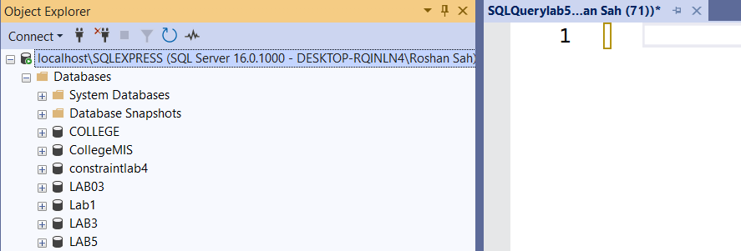

- Create a table student (sid, sname, marks, address) and studentlog (logid, sid, actiontype, actiontime)
Querry: CREATE TABLE student(
sid int primary key,
sname varchar(30),
marks int,
saddress varchar(40)
)
Select * from student
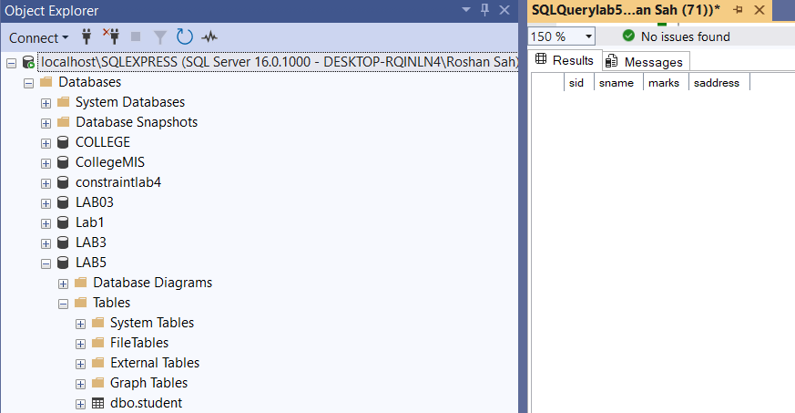

CREATE TABLE studentlog(
logid int identity(1,1),
sid int ,
actiontype varchar(30),
actiontime date
foreign key(sid) references student(sid)
)
select * from studentlog
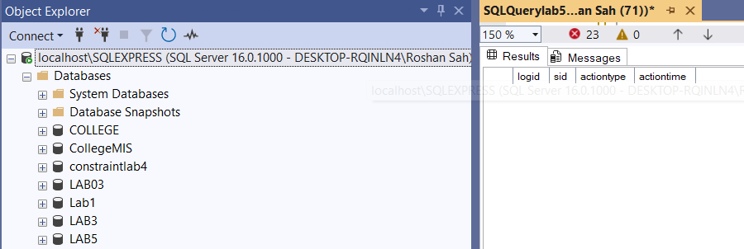

- Create a trigger studentlog trigger in which log of student table inserted automatically when new data inserted to student table
Querry:CREATE TRIGGER studentlog_trigger
ON student
AFTER INSERT
AS
BEGIN
INSERT INTO studentlog (sid, actiontype, actiontime)
SELECT sid, 'INSERT', GETDATE()
FROM inserted;
END;
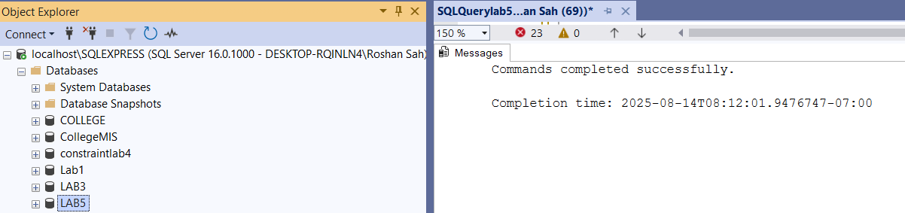

INSERT INTO student (sid, sname, marks, saddress)
VALUES (2, 'Roshan', 98, 'Kathmandu');
Select * from studentlog
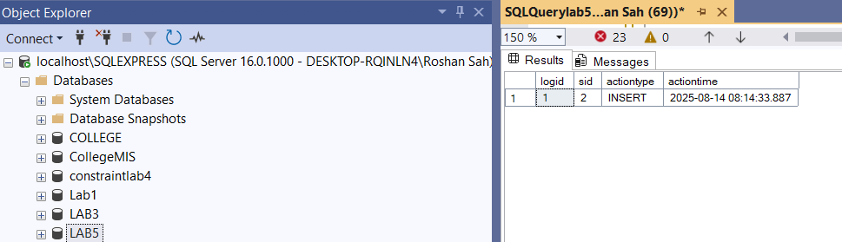

Select * from student
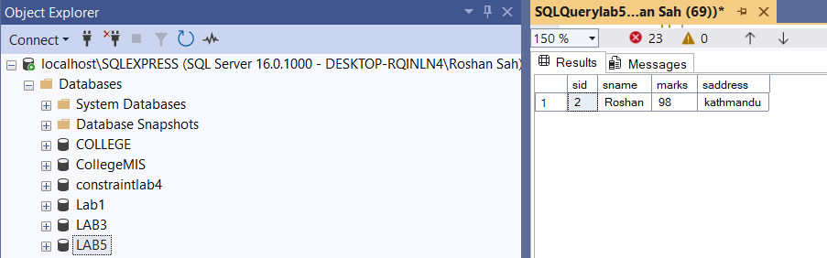

- Create a trigger ‘student_message’ after inserting dates to student table
Querry: CREATE TRIGGER student_message
ON student
AFTER INSERT
AS
BEGIN
PRINT 'New student record has been inserted into the student table.';
END;
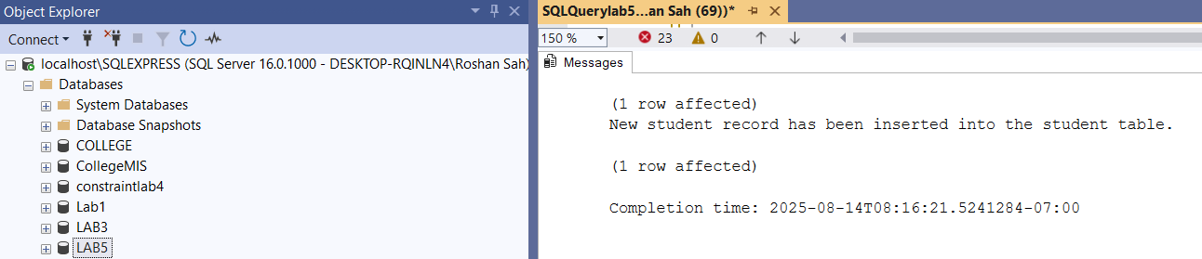

- Create a trigger ‘student_totalmarks”to find total marks and display it
Querry: CREATE TRIGGER student_totalmarks
ON student
AFTER INSERT
AS
BEGIN
DECLARE @total DECIMAL(10,2);
SELECT @total = SUM(marks)
FROM student;
PRINT 'Total marks of all students: ' + CAST(@total AS VARCHAR(20));
END;
INSERT INTO student (sid, sname, marks, saddress)
VALUES (10, 'Ram', 91, 'Kathmandu');
